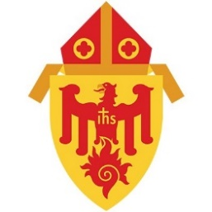
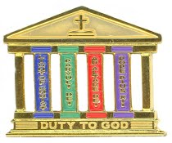
Pillars of Faith: Duty to God
Archdiocese of Chicago Application

Please Print

Scout’s First and Last Name________________________________________________ Age________

Address___________________________City_____________________State____ Zip_______

Email________________________ Phone__________ Parish ___________________Scout Unit #___

Scout Leader/ Counselor Name___________________________________________________

Address____________________________ City_____________________ State_____ Zip_____

Email________________________ Phone__________ Parish ___________________Scout Unit #___

Verification of earned Religious Emblems

Date Completed | Religious Emblem | Home Diocese when earned
 | Light of Christ
 | Parvuli Dei
 | Ad Altare Dei / Light is Life
 | Pope Pius XII

Scout Certification
I certify that I have earned all four Religious Emblems (Light of Christ, Parvuli Dei,
Ad Altare Dei /Light is Life, and Pope Pius XII) and can receive my Pillars of Faith Award.

Scout Signature: ___________________________Date: ___ / ___ / ___

Scout Leader / Counselor Certification
I certify that the above named scout has earned all four Religious Emblems (Light of Christ,
Parvuli Dei, Ad Altare Dei/ Light is Life, and Pope Pius XII), and can receive the Pillars of Faith Award.

Scout Leader Signature: ________________________Date: ___ / ___ /

VERIFICATION
******For Chicago Archdiocese Catholic Committee on Scouting Use Only*****

Dates Received Match? _______Counselor(s) Trained? ________Award Approved? ______

Checked and Approved by: _______________________________Date:________________

Signature: _________________________________________________________________

